**ASSIGNMENT 15.4**

**Problem Statement:**

Build and Deploy Hadoop word count program using Maven.

**Solution:**

**Maven installation:**

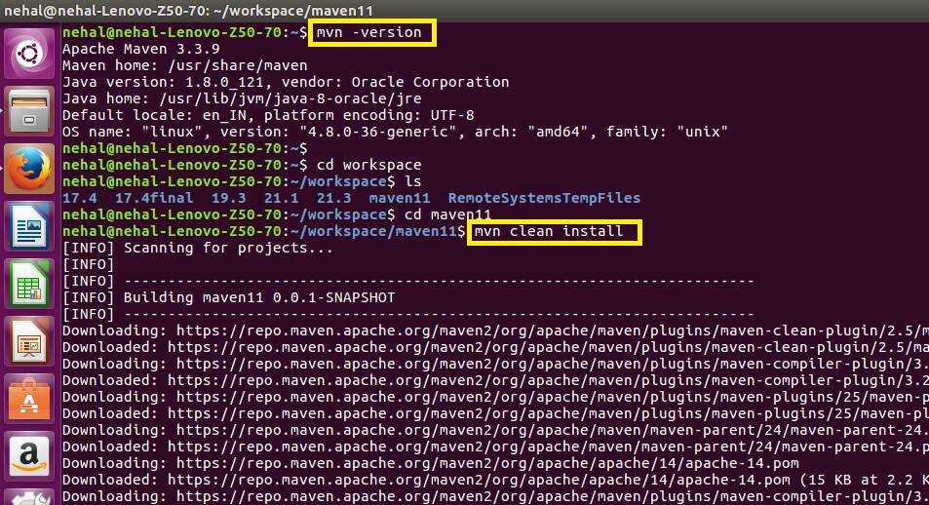

**Maven project built successfully:**

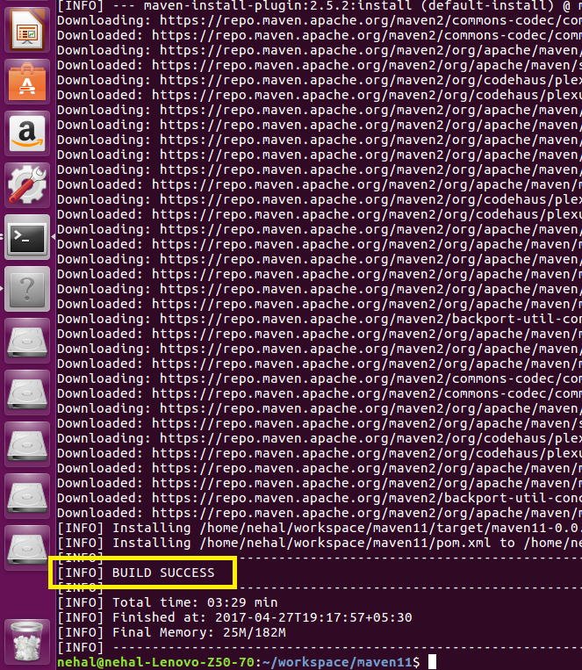

**Java code for word count:**

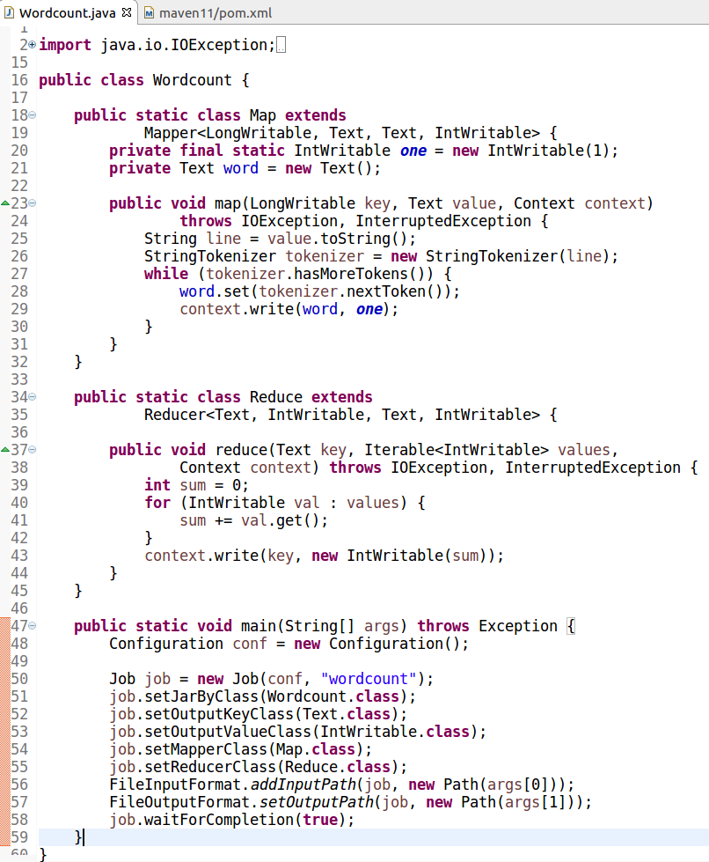

**Pom.xml file:**

All dependencies are included in this file.

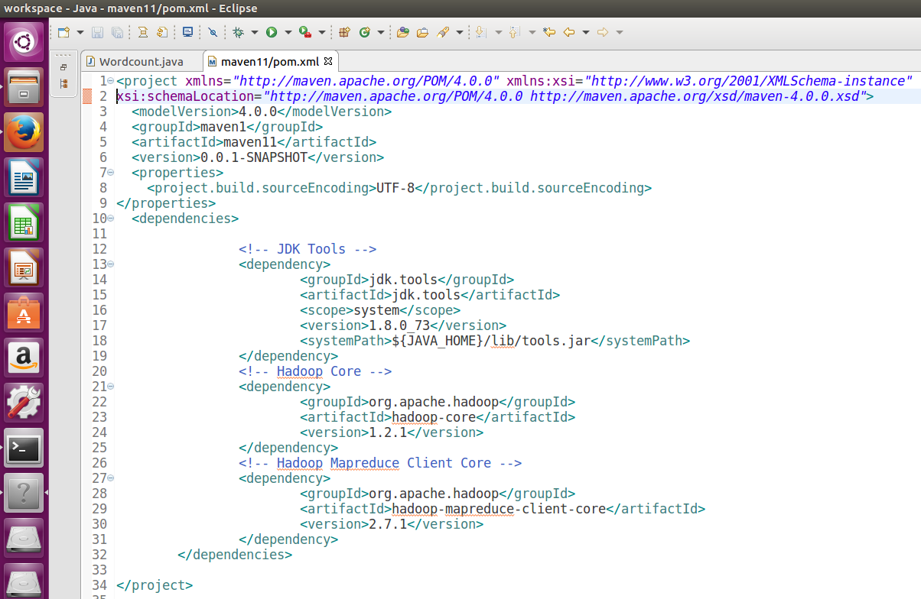

**Dataset:**

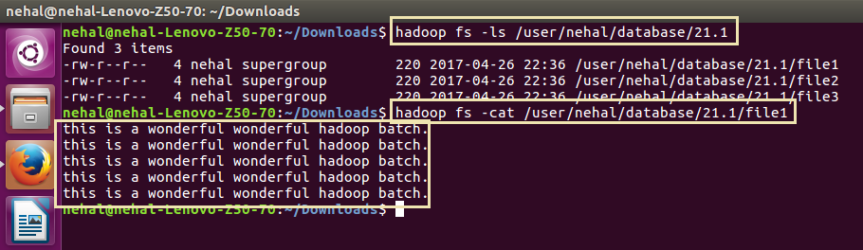

**Running maven project (jar file):**

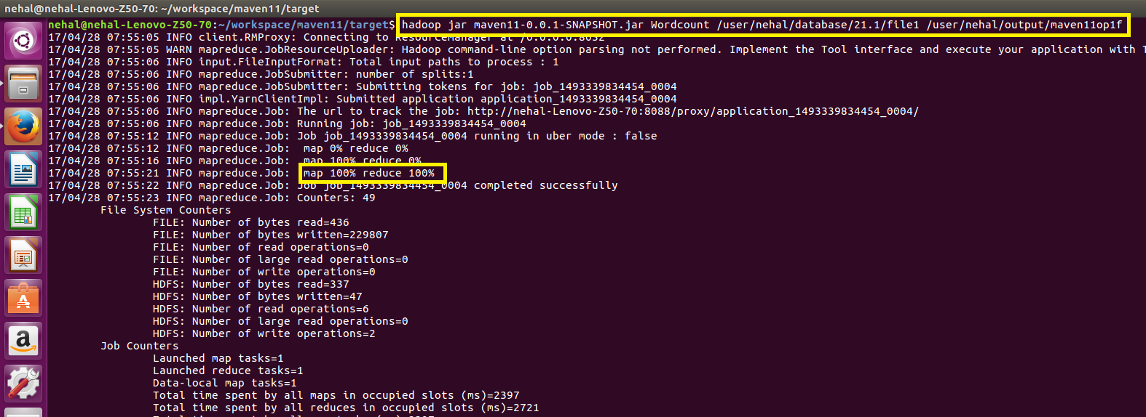

**Output:**

